Works available by SunJing
30 October 2026

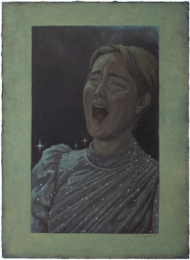 | SunJing  Her Tears, 2025  Acrylic on canvas  55 x 40 cm  21 5/8 x 15 3/4 in  Signed & dated verso  (SJ_1_2025) | € 4,800
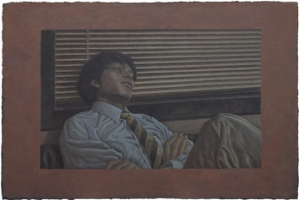 | SunJing  Beast at Bay, 2026  Acrylic on canvas  40 x 60 cm  15 3/4 x 23 5/8 in  Signed & dated verso  (SJ_1_2026) | € 5,000
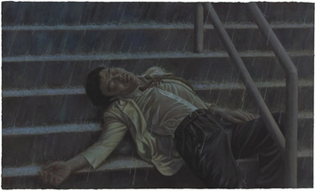 | SunJing  Rain in the City, 2025  Acrylic on canvas  60 x 100 cm  23 5/8 x 39 3/8 in  Signed & dated verso  (SJ_2_2025) | € 8,400
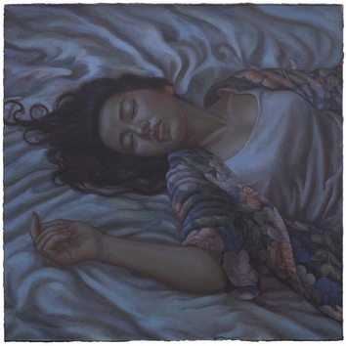 | SunJing  Folds, 2025  Acrylic on canvas  40 x 40 cm  15 3/4 x 15 3/4 in  Signed & dated verso  (SJ_3_2025) | € 4,500
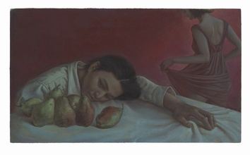 | SunJing  Pear Concerto, 2025  Acrylic on canvas  35 x 60 cm  13 3/4 x 23 5/8 in  Signed & dated verso  (SJ_4_2025) | € 4,800
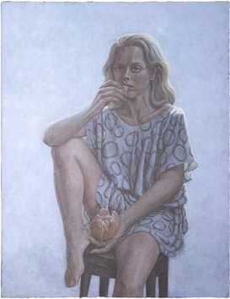 | SunJing  Sour, 2026  Acrylic on canvas  64 x 50 cm  25 1/4 x 19 3/4 in  Signed & dated verso  (SJ_2_2026) | € 5,400
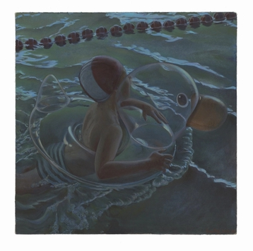 | SunJing  Sink and Swim, 2025  Acrylic on canvas  30 x 30 cm  11 3/4 x 11 3/4 in  Signed & dated verso  (SJ_5_2025) | € 4,000

